Week 4 Exercise 2

- Abstract
  - breezypythongui.py
    - Simplifies the user interface and event model for programmers by subclassing various classes in Python’s tkinter framework
  - cards.py
    - a command line interface application intended to simulate playing cards. Establishes the card and deck class definitions
  - cardsgui.py
    - a graphical application that leverages the classes within breezypythongui.py to represent a visual experience for cards.py
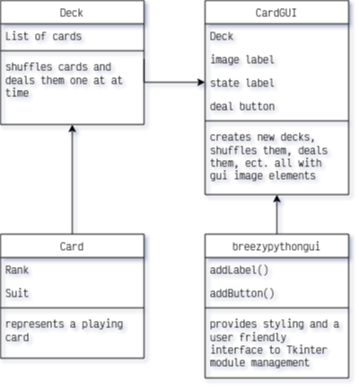
- breezypythongui.py
  - Ok, so this file is about 1100 lines, so we’re not going to break down everything, however this essentially provides a more user friendly interface to the Tkinter module built into Python. It aims to provide class methods that simplify the myriad optional arguments that the various tkinter widgets offer but are not always so obvious. It also aims to improve .grid placement within Frames. A few of the methods the CardsGUI.py leverages are:
    - EasyFrame – sub-class to Tkinter.Frame
      - __init__() - when instantiating an EasyFrame, it calls the parent-class’ constructor, passing many default values that aren’t normally established, as well as establishing the grid to build upon
      - addLabel() - when called will pass various default values concerning grid placement and color styles along to Tkinter.Label() method. Normally these functions are handled seperately when using vanilla Tkinter, however this bundles the functions (which are often called together anyway)
      - addButton() - similar to addLabel, but with tkinter.Button()
  - See https://lambertk.academic.wlu.edu/breezypythongui/ for more details

- cards.py
  - classes
    - Card
      - properties
        - ranks – a tuple of ints containing the numbers 1 through 13 (representitive of Ace through King for playing cards)
        - suits – a tuple of strings containing the suits Spades, Diamonds, ect
        - faceup – a boolean representing whether the card is face up or down (visibility to the user)
      - methods
        - __init__(rank, suit) – establishes a rank and suit for each individual card, and applies a face-down value
        - __str__() - overloads the built-in str() method to return a string representation of the rank and suit of the card
        - turn() - inverts the value of face-up
    - Deck
      - properties
        - list<cards> - a list containing the cards in the deck
      - methods
        - __init__() - establishes the empty list of cards and populates it based on all combinations of card ranks and suits
        - __str__() - overloads the built-in str() method to return a newline seperated concatenated string of all cards within the cards list property
        - __len__() - overloads the built-in len() function to return the length of it’s list of cards property only
        - shuffle() - calls the shuffle function of the random library, passing its list of cards as the argument
        - deal() - verifies there are still cards remaining in the deck by using the overloaded len() to return the length of cards list. If empty, return None, if not empty, return and remove the top card from the list
  - main()
    - instantiates a deck object
    - while the deck has cards remaining:
      - call deck.deal() which pops the top card off the list
      - print the card we just dealt
    - make a new deck, but shuffle it this time
    - while the deck has cards remaining:
      - call deal()
      - call card.turn() which inverts it’s boolean faceup value
      - print the card we just dealt
  - if __name__ blah blah
    - ensures that the main method is only run if the script is being executed as the root of an application. Since python technically runs everything when it builds, we don’t want to call main in the event we import this file into another file like, cardsgui.py…

- cardsgui.py
  - Classes
    - CardsGUI – sub-class to breezypythongui.EasyFrame
      - properties
        - deck – instantiates a deck object from cards.py
        - title – the title to be displayed for the GUI window made by EasyFrame
        - imageLabel – calls addLabel() from EasyFrame and stores a label about an image
        - stateLabel – calls addLabel() again and stores a label about a state
        - dealBtn – calls addButton() from EasyFrame and stores a button that calls CardsGUI.deal() as its on-click event
      - methods
        - __init__() -
          - overrides EasyFrame.__init__(), the parent class’ constructor, by passing a default value to the EasyFrame’s title property
          - sets labels and button with tkinter.grid values
          - instantiates two more buttons
            - shuffle button with deck.shuffle() on-click event
            - new deck button with CardGUI.newDeck() on-click event
        - deal() - calls its deck’s deal() method refreshes images and applies label information based on the card produced
        - suffle() - calls its deck’s shuffle() method
        - newDeck() - replaces its deck with a new Deck object and refreshes images and labels
        - refreshImage() - stores a PhotoImage tkinter widget of the card passed to it and modifies its label accordingly
  - main()
    - calls tkinter.Frame.mainloop(), the core of the application’s event listener loop

